Day 2

#write a program to input a year and check weather it is leap year or not

Code:-

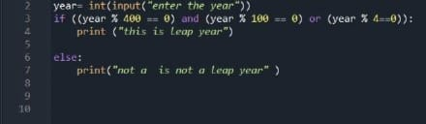

Output:-

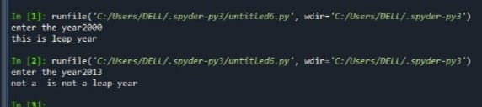

#write a program to input three number and print the largest using nested if

Code:-

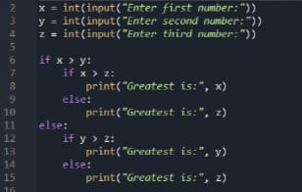

Output:-

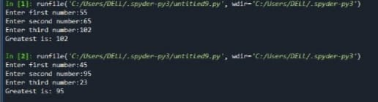

#Write a program to print sum of all even and odd number from 10 to 20

Code:-

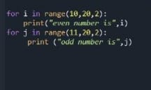

Output:-

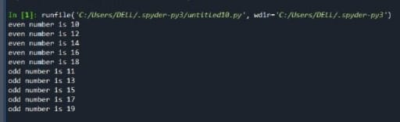

#write a program to take input from the user and find factorial

Using loop

Code:-

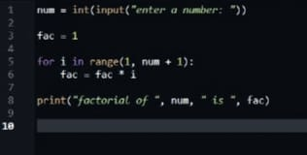

Output:-

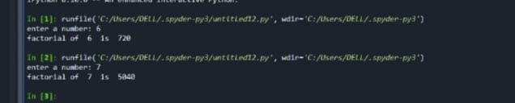

#write a program to find the sum of series 1/1!+1/2!+1/3!..........+1/n! where n is given by user

Code:-

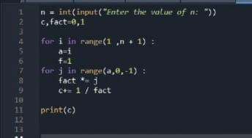

Output:-

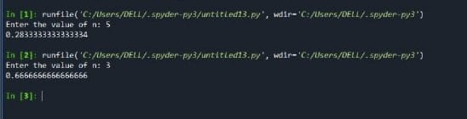

#Write a program to input three number from the user and arrange in ascending order using nested loop

Code:-

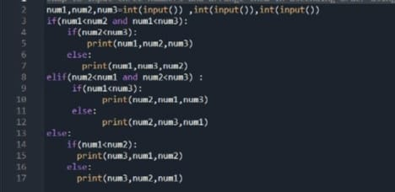

Output:-

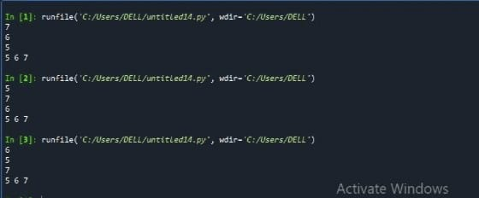

#wap to print health status of a person using bmi

#as shown in the following table:-

BMI weight status

below 18.5 under weight

18.5- 24.9 normal

25.0-29.9 over weight

30.0 and above

Code:-

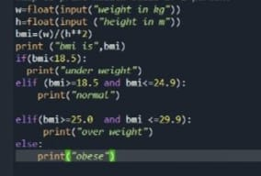

Output:-

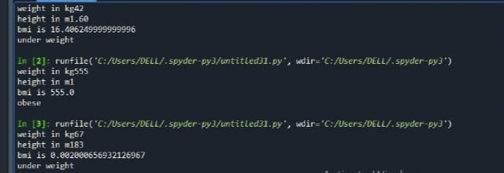

#WAP to take input and operator fro user and do arithematic operation

Code:-

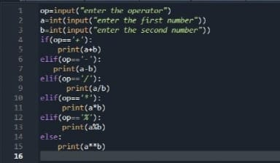

Output:-

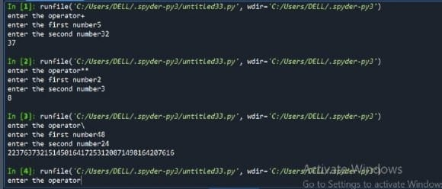

# wap program to input marks of a student print his grade

Marks grade

90 to 100 A+

80 to 90 A

70 to 80 B+

60 to 70 B

50 to 60 C

40 to 50 D

30 to 40 E

Less than 30 F

Code:-

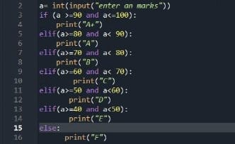

Output:-

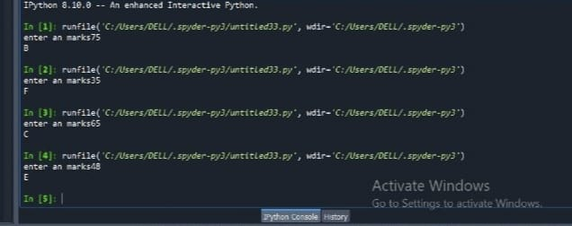

# wap program to input from user and find wether it is even or odd

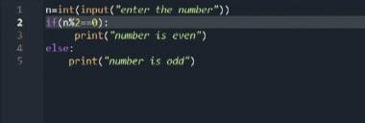

Output:-

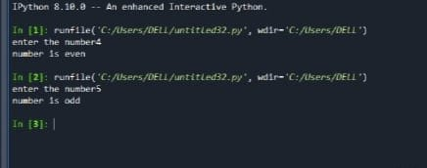

obese